Supplementary information for:

Key epidemiological parameters and effectiveness of vaccination

of Omicron BA.1 variant from real-world data in China

Kangguo Li^{1,4}, Feng Ruan^{2,4}, Zeyu Zhao^{1,3,4}, Shanshan Yu¹, Zimei Yang¹, Xuebao Zhang², Xiling Yin², Wenhua Mei^{2*}, Tianmu Chen^{1*}
¹State Key Laboratory of Molecular Vaccinology and Molecular Diagnostics, School of Public Health, Xiamen University, Fujian, China.
²Zhuhai Center for Disease Control and Prevention, Guangdong, China.
³Université de Montpellier, Montpellier, France; CIRAD, Intertryp, Montpellier, France; IES, Université de Montpellier-CNRS, Montpellier, France.
⁴These authors contributed equally to this work: Kangguo Li, Feng Ruan, Zeyu Zhao.
* Corresponding authors:
Tianmu Chen, chentianmu@xmu.edu.cn,13698665@qq.com
Wenhua Mei, 1297648405@qq.com

Supplementary Figure 1. Geographical distribution of cumulative cases of this outbreak in Zhuhai, China.

Supplementary Figure 2. Crude second attack rate (SAR) of infector age of Omicron variant in Zhuhai, China.

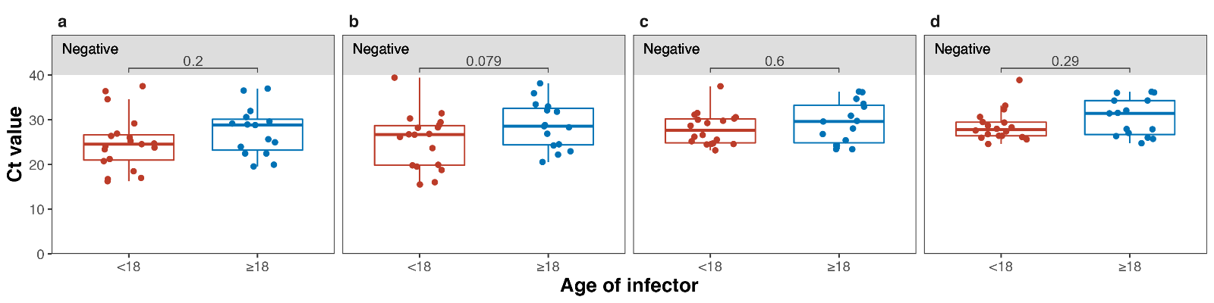

Supplementary Figure 3. Cycle threshold (Ct) value of infector age of Omicron variant in Zhuhai, China. a and b are Ct value of ORF gene and N protein on nasopharyngeal swab, respectively. c and d are Ct value of ORF gene and N protein on throat swab, respectively.

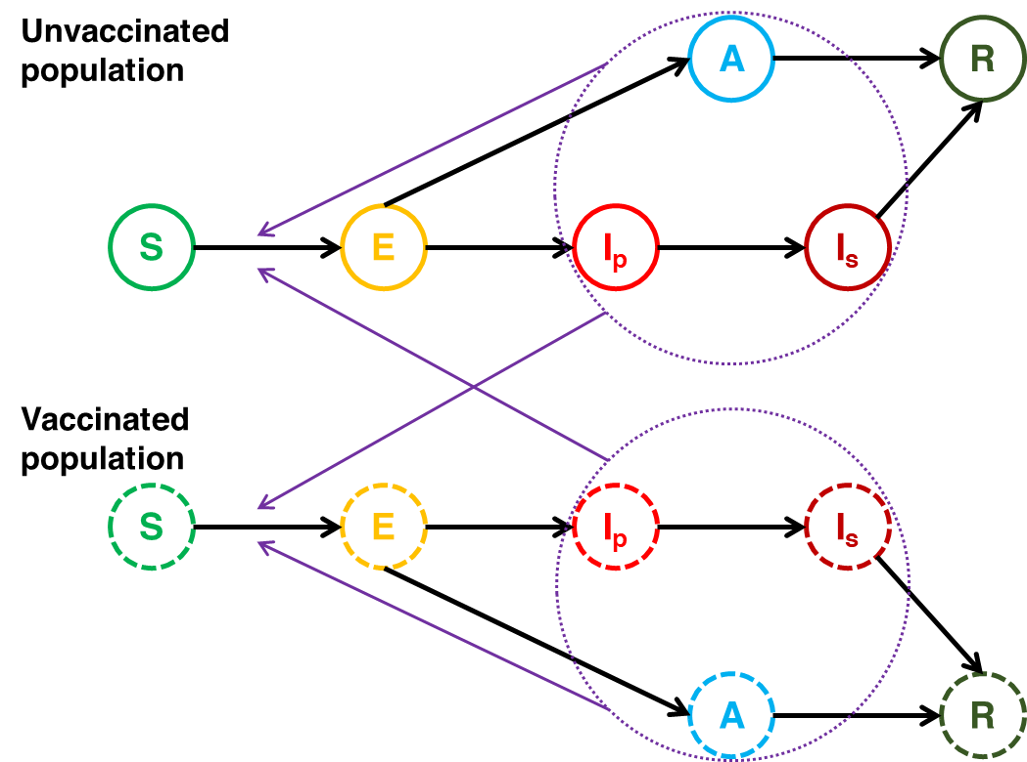

Supplementary Figure 4. Flowchart of the SEIR+ model of the study.

Supplementary Table 1. Basic information of infections of Omicron variant in Zhuhai, China, January 2022.
ID | Gender | Age | Type | Vaccine dose* | Cluster of infections | Date of positive test | Date of infections report | Date of onset | Possibly exposed date
1 | Female | 53 | Mild | 3 | Kindergarten | 2022/1/13 | 2022/1/14 | 2022/1/13 | 2022/1/10 to 2022/1/12
2 | Female | 9 | Mild | 2 | Primary school | 2022/1/13 | 2022/1/14 | 2022/1/13 | 2022/1/10 to 2022/1/11
3 | Female | 39 | Asymptomatic | 2 | Dental clinic | 2022/1/13 | 2022/1/14 | -- | 2022/1/8 to 2022/1/13
4 | Male | 36 | Mild | 2 | Undistinct | 2022/1/13 | 2022/1/14 | 2022/1/11 | 2022/1/7 to 2022/1/11
5 | Female | 34 | Moderate | 2 | Dental clinic | 2022/1/14 | 2022/1/14 | 2022/1/8 | 2022/1/4 to 2022/1/8
6 | Female | 9 | Moderate | 2 | Primary school | 2022/1/14 | 2022/1/14 | 2022/1/11 | 2022/1/7 to 2022/1/11
7 | Male | 4 | Mild | 1 | Kindergarten | 2022/1/14 | 2022/1/14 | 2022/1/11 | 2022/1/7 to 2022/1/11
8 | Female | 36 | Mild | 3 | Primary school | 2022/1/14 | 2022/1/15 | 2022/1/14 | 2022/1/10 to 2022/1/11
9 | Female | 41 | Mild | 3 | Kindergarten | 2022/1/15 | 2022/1/16 | 2022/1/15 | 2022/1/10 to 2022/1/13
10 | Male | 3 | Mild | 1 | Kindergarten | 2022/1/15 | 2022/1/16 | 2022/1/15 | 2022/1/10 to 2022/1/13
11 | Female | 10 | Mild | 2 | Primary school | 2022/1/15 | 2022/1/16 | 2022/1/13 | 2022/1/10 to 2022/1/11
12 | Female | 43 | Mild | 2 | Undistinct | 2022/1/16 | 2022/1/16 | 2022/1/16 | 2022/1/10 to 2022/1/15
13 | Female | 33 | Moderate | 1 | Dental clinic | 2022/1/16 | 2022/1/16 | 2022/1/15 | 2022/1/7 to 2022/1/13
14 | Female | 27 | Mild | 2 | Kindergarten | 2022/1/16 | 2022/1/17 | 2022/1/14 | 2022/1/10 to 2022/1/13
15 | Female | 30 | Mild | 3 | Undistinct | 2022/1/16 | 2022/1/17 | 2022/1/15 | 2022/1/10 to 2022/1/14
16 | Male | 10 | Mild | 0 | Primary school | 2022/1/17 | 2022/1/17 | 2022/1/15 | 2022/1/10 to 2022/1/11
17 | Female | 10 | Mild | 2 | Primary school | 2022/1/17 | 2022/1/17 | 2022/1/14 | 2022/1/10 to 2022/1/11
18 | Male | 1 | Mild | 0 | Undistinct | 2022/1/17 | 2022/1/17 | 2022/1/15 | 2022/1/10 to 2022/1/14
19 | Male | 3 | Mild | 1 | Kindergarten | 2022/1/17 | 2022/1/18 | 2022/1/16 | 2022/1/10 to 2022/1/13
20 | Female | 21 | Moderate | 3 | Kindergarten | 2022/1/17 | 2022/1/18 | 2022/1/14 | 2022/1/10 to 2022/1/13
21 | Female | 56 | Mild | 2 | Kindergarten | 2022/1/18 | 2022/1/18 | 2022/1/17 | 2022/1/10 to 2022/1/13
22 | Female | 24 | Mild | 3 | Kindergarten | 2022/1/18 | 2022/1/18 | 2022/1/16 | 2022/1/13 to 2022/1/13
23 | Male | 8 | Mild | 2 | Primary school | 2022/1/18 | 2022/1/18 | 2022/1/17 | 2022/1/13 to 2022/1/13
24 | Female | 4 | Moderate | 1 | Kindergarten | 2022/1/18 | 2022/1/18 | 2022/1/15 | 2022/1/10 to 2022/1/13
25 | Female | 33 | Asymptomatic | 2 | Dental clinic | 2022/1/18 | 2022/1/18 | -- | 2022/1/7 to 2022/1/13
26 | Female | 25 | Mild | 3 | Kindergarten | 2022/1/18 | 2022/1/19 | 2022/1/18 | 2022/1/10 to 2022/1/15
27 | Male | 41 | Moderate | 3 | Undistinct | 2022/1/18 | 2022/1/19 | 2022/1/18 | 2022/1/11 to 2022/1/15
28 | Male | 4 | Mild | 3 | Kindergarten | 2022/1/18 | 2022/1/19 | 2022/1/17 | 2022/1/10 to 2022/1/13
29 | Male | 3 | Moderate | 1 | Kindergarten | 2022/1/19 | 2022/1/20 | 2022/1/18 | 2022/1/10 to 2022/1/17
30 | Female | 22 | Mild | 0 | Kindergarten | 2022/1/19 | 2022/1/20 | 2022/1/19 | 2022/1/10 to 2022/1/15
31 | Female | 4 | Mild | 3 | Kindergarten | 2022/1/19 | 2022/1/20 | 2022/1/19 | 2022/1/10 to 2022/1/13

Supplementary Table 1 (continued).
ID | Gender | Age | Type | Vaccine dose* | Cluster of infections | Date of positive test | Date of infections report | Date of onset | Possibly exposed date
32 | Male | 3 | Mild | 1 | Kindergarten | 2022/1/19 | 2022/1/20 | 2022/1/19 | 2022/1/12 to 2022/1/13
33 | Female | 4 | Mild | 0 | Kindergarten | 2022/1/20 | 2022/1/20 | 2022/1/20 | 2022/1/10 to 2022/1/13
34 | Male | 13 | Mild | 0 | Undistinct | 2022/1/20 | 2022/1/21 | 2022/1/20 | 2022/1/12 to 2022/1/15
35 | Female | 35 | Moderate | 2 | Undistinct | 2022/1/21 | 2022/1/22 | 2022/1/20 | 2022/1/12 to 2022/1/20
36 | Female | 35 | Mild | 2 | Undistinct | 2022/1/21 | 2022/1/22 | 2022/1/20 | 2022/1/17 to 2022/1/20
37 | Male | 31 | Moderate | 2 | Undistinct | 2022/1/21 | 2022/1/22 | 2022/1/19 | 2022/1/16 to 2022/1/19
38 | Female | 5 | Asymptomatic | 3 | Kindergarten | 2022/1/21 | 2022/1/22 | -- | 2022/1/10 to 2022/1/13

*0 vaccine dose: unvaccinated or administered 1 dose within 14 days. 1 vaccine dose: administer 1 dose vaccine after 14 days or 2 doses within 14 days. 2 vaccine doses: administer 2 dose vaccine after 14 days or administer booster dose within 14 days. 3 vaccine doses: administer 3 dose vaccine after 14 days.

Supplementary Table 2. MCMC simulate outcome of vaccine effectiveness.
Group | Indexes | Median | IQR
Vaccinated | Total attack rate (TAR) | 89.90% | 88.70%--90.90%
 | Duration of outbreak DO) | 150 | 143--164
 | Peak time (PT) | 40 | 33--47
 | Attack rate of peak time (PAR) | 28.31% | 24.00%--33.33%
Non-vaccinated | Total attack rate (TAR) | 99.50% | 99.3%--99.60%
 | Duration of outbreak DO) | 117 | 101--140
 | Peak time (PT) | 31 | 26--36
 | Attack rate of peak time (PAR) | 17.00% | 14.34%--20.08%

Supplementary Table 3. Parameters of the SEIR+ model.
Parameter | Description | Distribution | Source
$$1/ω+1/{ω^{''}}$$ | Incubation period: difference of date between exposed and the onset of symptomatic infections | Gamma (3.66, 1.19) | Fitted
$$1/{ω^{''}}$$ | The infectious period of pre-symptomatic infections | Gamma (0.91, 0.87) | Fitted
$$1/{ω^{'}}$$ | Difference of date between exposed and positive test of asymptomatic infections | Gamma (3.66, 1.19) | Assumption
$$1/{γ^{'}}$$ | Period of category I transferred into category R | 4.5 | Assumption
$$1/γ$$ | Period of category A transferred into category R | 4.5 | Assumption
$$p$$ | Proportion of asymptomatic infections | 0.31 | Reference⁵
$$R_{0}$$ | Basic reproductive number | 5 | Reference²⁴

